Practical – 1

**AIM:**

Create a webpage demonstrating “Spoural Event '' and its description, providing a link for registration page. Registration form of the student for “Spoural Event'' having different fields like type of event, event listing, Student ID/Group, Branch, etc

**Source Code:**

<!DOCTYPE html>

<html lang="en">

<head>

<meta charset="UTF-8">

<meta http-equiv="X-UA-Compatible" content="IE=edge">

<meta name="viewport" content="width=device-width, initial-scale=1.0">

<title>Document</title>

</head>

<body background="dj.jpeg"; style="background-repeat:no-repeat;background-size: 50%">

<p>

<font size="70"face="arial"color="black"><b><i><center>SPOURAL'23</center></i></b></font

</p>

<h4 align="right">THE BIGGEST SPORTS AND CULTURAL FESTIVAL</h4>

<h2 align="right">THE MOST AWAITED MOMENT</h2>

<h3 align="right"><i>We do not remember the days ,we remember the</i></h3>

<h2 align="right"><i>Moments</i></h2>

<h4 align="right"><i>Get ready to participate in these moments of events</i></h4>

<div align="right">

<a href="/registerform.html"><h3 align="right"></h3><b><i>REGISTER HERE</i></b></h3></a>

</div>

</body>

</html>

<!DOCTYPE html>

<html lang="en">

<head>

<meta charset="UTF-8">

<meta http-equiv="X-UA-Compatible" content="IE=edge">

<meta name="viewport" content="width=device-width, initial-scale=1.0">

<title>Document</title>

</head>

<body style="background-color: aqua;">

<form action="">

<div><br> NAME:<input type="text"></div>

<div><br> STUDENT ID:<input type="text"></div>

<div><br>INSTITUTE:<input type="text"></div>

<div><br>BRANCH:<input type="text">

<div><br> SEMISTER:<input type="number">

<div><br>CONTACT NO:<input type="number"></div><br>

<div>Email-ID:<input type="email"></div>

<br><div>GENDER: MALE<input type="radio">FEMALE<input type="radio"></div>

<br>

<div>INTERESTED EVENTS:<br><br>BADMINTON<input type="checkbox">

<br>VOLLEYBALL<input type="checkbox">

<br>FOOTBALL<input type="checkbox">

<br>TUG OF WAR<input type="checkbox">

<br>KABBADI<input type="checkbox">

<br>DANCE<input type="checkbox">

<br>SINGING<input type="checkbox">

<br>STANDUP<input type="checkbox">

<br>POETRY<input type="checkbox">

<br>PAINTING<input type="checkbox">

</div>

<div><br><input type="submit" value="SUBMIT"></div>

</form>

</body>

</html>

**Output:**

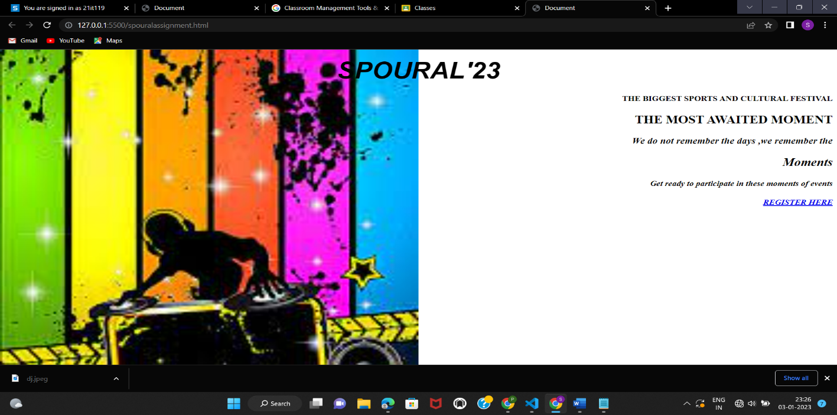

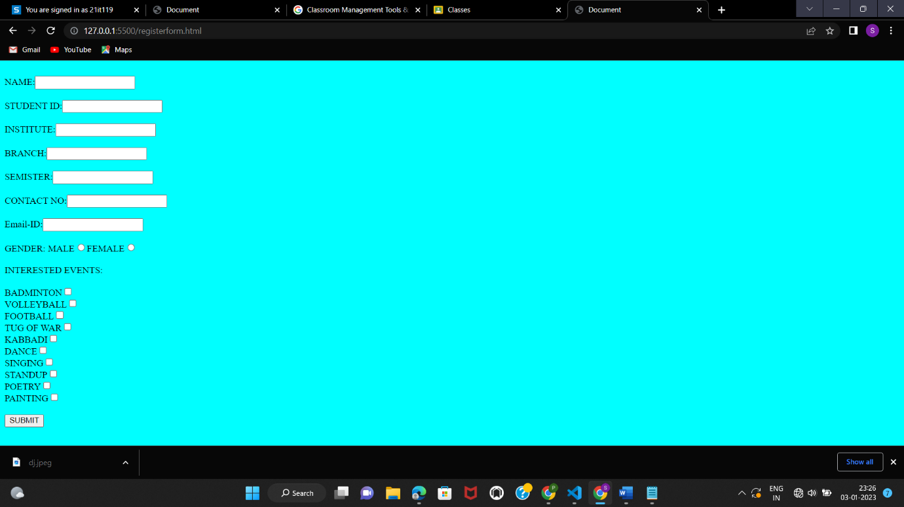

**Conclusion:**

In here we have learnt how to create webpage using HTML only ,its different types of tags and form properties.

**Course Outcome:**

Understanding the tools and technologies to design &develop static and dynamic web pages/apps.